Enter report Title (This is Title style)

Subtitle (This is subtitle style)

Version: version #(This is Subtle Reference style- remove if not relevant)
Date:
EEA activity:

Author:
From: E

Contributors: co-authors, or delete line
From: organisation

Contents (Toc Heading style)
Functions of the template 3
1.1 Meeting EEA report editing chart 3
1.1.1 EEA rules 3
1.1.2 Automating the rules 3
1.2 Definition of heading categories 3
1.3 Making caption entries 3
1.1.3 Making caption inserting easier 3
Using the template 3
1.4 Save and make available the template 3
1.5 Place the relevant styles into the QuickQtyle 3
Annex 1 – Sample Annex 3
1 Contains annex sections 3
1.2 Title Three Error! Bookmark not defined.

Table of figures (Table Title style)
Figure 1.1: how managing the label and caption 3
Figure 2.1: the quickstyle gallery 3

Acknowledgement (Table Title style)
Figure 1.1: how managing the label and caption 3
Figure 2.1: the quickstyle gallery 3

Functions of the template (Heading 1 style)
Normal style

Meeting EEA report editing chart (Heading 2 style)
The EEA report editing chart is based on simple rules, automation of which is complex. The purpose of this template is to make the automation of these rules more straightforward.

EEA rules (Heading 3 style)
The main text in EEA reports should be formatted using the ‘body text’ style.
The text is broken down into three levels: chapters, sections and sub-sections. They are numbered respectively: 1.1 and 1.1.1
The report must have a “reference” section, which is not a chapter and is not numbered.
The report may have several annexes that are numbered Annex 1, annex 2, etc.
Each annex may have to levels, equivalent to section and sub-section, numbered 1, 1.1 etc, within each annex.
Figures, maps, tables must be numbered as:
- Figure/ Table / Map {chapter number}. Rank in the chapter in chapters (e.g. “Figure 2.2.”) and
- Figure/ Table / Map A.{annex number}. Rank in the annex in annexes (e.g. “Figure 2.2.”)
- This is List Paragraph style
There is a table of contents that should recap all entries, including annex number (possibly sections / sub-sections in annexes).

Automating the rules
To automate the rules, there is no other solution than using the Word numbering facilities. These facilities are however rather demanding:
- Figure / tables / map numbering with reference to chapter and annex impose that chapter and annex are ‘Headings’
- Making reference to chapters / section / subsection / reference / annex (and annex section and sub-section) in the table of content impose that all are ‘headings’.
Annexes could be processed as tables (as automatic captions), but this would NOT allow numbering the figures / tables / maps into the Annexes as demanded.
- Numbering of figures with different rules between chapters and annexes impose to handle TWO sets of caption definitions, which is rather simple but must be anticipated.

Definition of heading categories
The simplest way to achieve the hierarchy of headings was implemented in this template on the following way:
- Chapters are heading 1, numbered (single digit)
- Sections are heading 2, numbered according to heading 1 (two digits)
- Sub-sections are heading 3, numbered, according to heading 1 and 2 (three digits)
- References are heading 4, NOT numbered
- Annexes are heading 5, numbered restarting at 1 for each annex
- Annex sections are heading 6, restarting at 1 for each annex and dropping heading 1 to 5 numbering
- Annex sub-sections are heading 7, numbered after heading 6 and dropping heading 1 to 5 numbering
- This is ListParagraph style
In Word 2010, this numbering is both simpler to do and more complicated to update than in word 2003. Word 2010 uses the concept of ‘Multilevel list’, which is decoupled from the template. This allows setting a single numbering for many templates but by contrast makes it impossible to update substantially the numbering from the template.
Hence, it is strongly recommended NOT having any action regarding ‘numbering’ of the headings in the template; any change CANNOT be simply restored, except altering the “multilevel list’ that is beneath the template .

Making caption entries
Maps, tables and figures work on the same principles. The menu box “insert caption” proposes selecting a “label” (e.g. Figure, or Figure A, etc.) and using a caption which is automatically numbered. The caption and the label are different thing: the first is what is displayed, the latter is how to identify the entry.
Figure 1.1: how to manage the label and caption This is Quote style
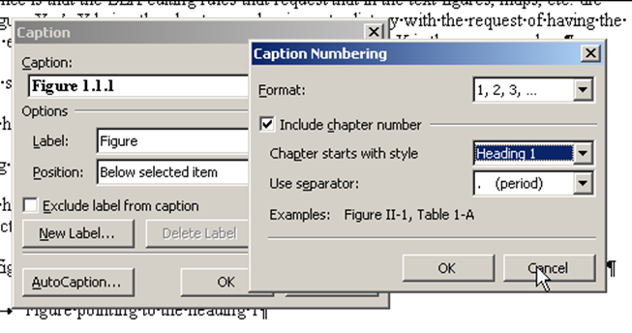

In Figure 1.1 above, the numbering is being set to include chapter number and use heading 1. This figure is in a chapter and the automatic caption “Figure 1.1: how to manage the label and caption” reflects this.

When making a figure that is inside an annex, the chapter number to include is heading 5. The same process should be used, but with the following differences:
- Caption is modified to include “A” before numbering,
- Reference to chapter is heading 5 and not 1
- The label must be different; otherwise it would conflict with the label used for figures in chapter.
Figure 1.2: managing settings of figures in annex
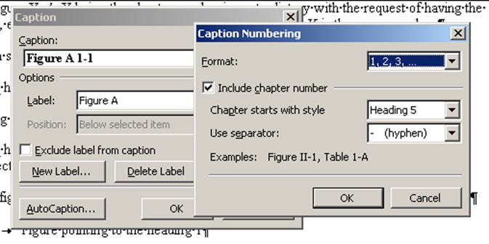

As user, prepare couples Figure /FigureA, Map/MapA, Table/TableA to ensure fluent caption inserting.
Captions are by default set to the “caption” style, and it is not that obvious to use the style “graphic title” instead.
This style is present in the template, and can be changed afterward (trick: let the system set as “caption”, select all “caption” and replace by “graphic title).

Map 1.1 Titles for maps and other graphics use the ‘Graphic title’ style
Place the map here

Notes: if there are any notes then they appear immediately after the graphic, before the source. Both notes and source should use the ‘Graphic source/notes’ style.
Source: Siebert et al. (2007). Graphic source/notes’ style

Making caption inserting easier
To facilitate caption inserting, create an entry in the QuickParts facility.
For example, keying ilfigA, will result after pressing F3 into

Example Title 3

Title 4

Title 5

Title 6

Title 7

Using the template

Save and make available the template

Heading 2

Heading 2
To make the template useful, save it where the templates are in your configuration. In many computers (PCR) they are stored at:
C:\Documents and Settings\your_name\Local Settings\Application Data\Microsoft\Word\STARTUP\templates
Create a new document based on the template and when familiar with the way to use it, delete all text with the grey underlining.
To avoid doing it every time, save the template as template with another name…
Footnote citations in the text appear at the end of the sentence, separated by a space, in brackets and followed by the punctuation ( ).

Place the relevant styles into the QuickStyle
Quickstyle gallery is the large part of the ribbon.
Figure 2.1: the quickstyle gallery This is quote style
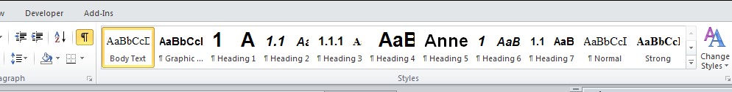

This gallery is helpful to place the most commonly used styles and apply them, just by clicking (if the mouse is on a style, it shows an approbatory display).

Heading 3

Title 4

Title 5

Title 6

Title 7

Heading 1

Heading 2

Heading 3

Heading 4

Heading 5

Heading 6

Heading 7

Heading 1

Heading 2

Heading 3

Heading 4

Heading 5

Heading 6

Heading 7

Annex 1 – Sample Annex (Style 1 – Annex)
Normal style.
- Contains annex sections (Style 2 – Annex)
Normal style.

With other subsections (Style 3 – Annex)
Normal style.

Annex 2
- Contains annex sections (Style 2 – Annex)
  - With other subsections (Style 3 – Annex)
  - With other subsections (Style 3 – Annex)
  - With other subsections (Style 3 – Annex)

Footnote style is footer

